assignment #04

Course: CHE 341: Chemical Process Control
Term: Spring 2026
Professor: Dr. Michael Caracotsios
Office: EIB 244

Cell Phone: (630) 696-0934
E-mail: mcaracot@uic.edu

Name: _________________________________
Due Date: Friday, March 20th TA’s Mailbox

INSTRUCTIONS FOR ASSIGNMENT DELIVERY

- Prepare a typed report of your assignment.
- Include this cover page with your name in the report.
- Upload your report as a PDF file by the Due Date and Time(6:00PM) on the UIC Blackboard.
- Place a hard copy of your report as a PDF file by the Due Date and Time(Closing of the Business Day) in the TA’s mailbox.

- Assignments that are not typed will not be accepted.
- Late Assignments will not be accepted without prior approval.
- You may use the Internet as well as ChatGPT or other public tools as long as you place a written statement about their use in your assignment report

Problem A: Dissolved Oxygen (DO) Process Control

Air at atmospheric pressure is injected in the bottom of a bio-reactor as shown in the schematic. The sparger creates bubbles in the reactor while the mixer reduces their size and facilitates the transport of oxygen from the bubbles to the liquid phase (broth) which is maintained at constant temperature equal to 35 ºC. The mass transfer rate of oxygen from the bubbles to the broth is given by the Newton’s law.
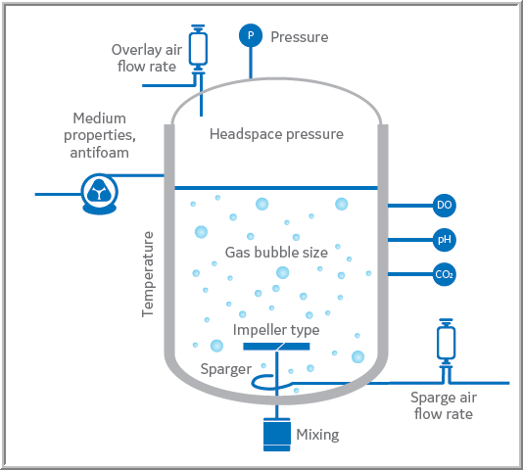

Oxygen is consumed in the liquid phase by the cells as they react with the substrate. The rate of consumption of oxygen is given by the equation: where x is the cell concentration which is assumed to be constant. The following data are available for this biological process.

The flow rate of air in the mass transfer coefficient equation is in ft³/min. The objective is to control the dissolved oxygen (DO) concentration in the broth by manipulating the air flow rate.

- Develop a dynamic model for the concentration of oxygen in the broth. Next taking the Laplace transform of the dynamic model and performing the proper linearization and Skögestad approximations derive the FOPTD transfer function of this process and calculate the process gain lag time and time delay
- Perform a dynamic simulation until steady-state is reached. Then perturb the flow rate of air by 10% and from the response calculate the process gain, lag time and time delay.
- Compare the values from your dynamic simulation with the values obtained by deriving the transfer function from the Laplace transform of the dynamic model and report the percent errors.

Assumptions and other pertinent data:
For the necessary physical properties, you may use ASPEN Plus to obtain the appropriate parameter values and you may assume that the air contains 79% Nitrogen and 21% Oxygen. You may also assume that the broth has the properties of water. The dissolved oxygen(DO) sensor has a lag time equal to and a repeatability of

